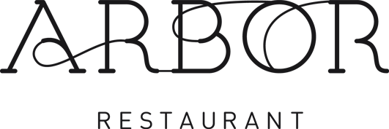
Our Supplier Showcase Menu
Thursday 6th March

For the Table
New Forest Wild Mushroom Arancini and Black Garlic Aioli (V)
(Gluten, Milk, Egg)
(New Forest Mushrooms. Isle of Wight Garlic Farm and Country Fare)

To Start
Wild Garlic and Potato Soup, Coastal Cheddar Espuma
(Dairy)
(Foraged by Ourselves, Ford Farm Cheese and Country Fare)

From The Fishmonger
Poached Chalk Stream Trout with Smoked Trout and Samphire Butter Sauce
(Fish, Milk)

(Premier Fish and Chalk Stream Trout)

From The Butcher
Slow Cooked Beef Cheek with Bone Marrow Butter, Confit Onion Tart Tatin
(Gluten, Milk, Sulphites, Egg)
(County Foods)

To Finish
Poached New Forest Rhubarb, Egg Custard, Stem Ginger Ice Cream
(Milk, Eggs, Gluten)

(Fluffetts Farm and Country fare)

£49 per person

